**Update Drivers:**

1. It's best to let Windows install drivers for your hardware automatically. You should avoid manually updating a driver unless Windows is unable to find a driver for one of your devices but you were able to obtain one some other way, or if technical support personnel ask you to install drivers from a disc or from the device manufacturer's website. If you decide to manually update a driver, here's how:

You must be logged on as an administrator to perform these steps.

1. Open Device Manager by clicking the **Start** button Picture of the Start button, clicking **Control Panel**, clicking **System and Maintenance**, and then clicking **Device Manager**.‌ Administrator permission required If you are prompted for an administrator password or confirmation, type the password or provide confirmation.
2. In Device Manager, locate the device you want to update, and then double-click the device name.
3. Click the **Driver** tab, and then click **Update Driver** and follow the instructions.
4. When you install a hardware or plug in a new device Windows 7 / Vista automatically selects the best driver. But sometimes you get a CD with your device that includes a driver with more features and a software too. You can also find the latest driver from the Company’s website that made the external device or hardware that you bought. If you don’t know how to update your device or hardware driver, then here is the easy way to do it.

***Note:****Now, Here let me explain you “****How To Update Your Graphic Card or Display Adapter ?****”.*

Go to **Start**and right-click on **Computers** and select **Manage**. This will bring the **Computer Management** window, now on the left sidebar select **Device Manager** as shown in the screenshot below.

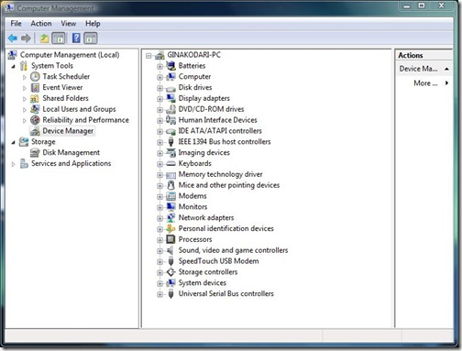

Now, simply select the device who’s driver you want to update. Suppose you want to update your Graphic card’s driver, then go to **Display Adapters** and right click on your card’s name(In my case it is Nvidia Geforce 9600GT) and finally click **Update Driver Software** as shown in the screenshot below.

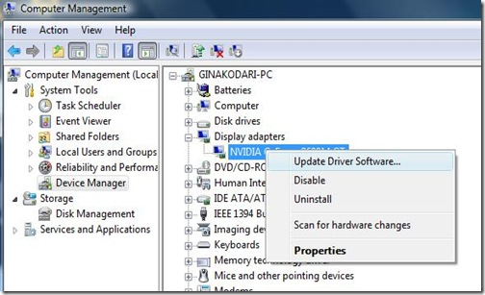

Once you are done. It will open a windows like the one shown below.

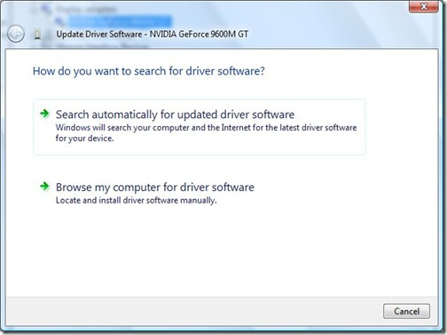

You have two options here, if you want to install a driver that came with your device or hardware, then select **Browse my computer for driver software**.

It will then open a window similar like the one shown below.

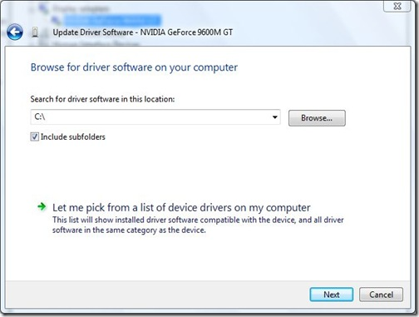

Click **Browse** and locate your driver, once it’s done simply click **Nex**t and Windows 7 / Vista will start installing the driver.

**Step 2.** After installing a driver, restart the PC and work with your computer and its devices for a day or so.

**Avoid untested drivers from device manufacturers:**

Many device manufacturers make new and unproven drivers (called “beta” versions) available from their websites for download by the adventurous few who can accept the risk associated with trying untested versions. **It is not recommended to install beta version device drivers** on your primary business or personal computers. Make sure that any driver update that you’re downloading and installing on your computer has been fully tested for compatibility with your system. Look for a “final” or “production” version to download instead.

Occasionally, even a final version device driver can have unforeseen interactions with other device drivers installed on your computer. Having a way to undo the effects of a broken driver install is essential, especially if the new driver causes conflicts, errors, or other problems. The Windows Restore Point functions discussed above do provide basic roll-back functionality, but it’s always wise to **perform a full backup** of the system and any important documents for “maximum insurance” against any unforeseen problems associated with an unwanted driver installation.

### To manually install a printer driver

1. Open Devices and Printers by clicking the **Start** button Picture of the Start button, and then, on the Start menu, clicking **Devices and Printers**.
2. Right-click the printer you want to update, and then click **Printer properties**.
3. Click the **Advanced** tab.
4. Click **New Driver**, and then follow the instructions in the Add Printer Driver wizard.

To ensure all of your hardware remains up to date, see [**Automatically get recommended drivers and updates for your hardware**](http://windows.microsoft.com/en-in/windows7/automatically-get-recommended-drivers-and-updates-for-your-hardware).